LAB221 Assignment | Type: | Short Assignment
 | Code: | J2.S.P0119
 | LOC: | 100
 | Slot(s): | 1

Title
Use PreparedStatement in JDBC
Background Context
A PreparedStatement is a special kind of Statement object with some useful features. Remember, you need a Statement in order to execute either a query or an update. You can use a PreparedStatement instead of a Statement and benefit from the features of thePreparedStatement.
The PreparedStatement's primary features are:
- Easy to insert parameters into the SQL statement.
- Easy to reuse the PreparedStatement with new parameters.
- May increase performance of executed statements.
- Enables easier batch updates

Program Specifications
Create a program to update data using PreparedStatement in JDBC. The First, student should login MS SQL to create a database name “FU_DB” in MS SQL, then student creates a table name “Stocks” with fields:
- StockID: type is integer
- StockName: string
- Address: string
- DateAvailable: Date
- Note: string
Main functions described as below:

Function details:

- Generate data and display on the dialog
- Use JDBC to insert those data into “Stocks” table (must use PreparedStatement to insert data)
Expectation of User interface:
The screen should be as:

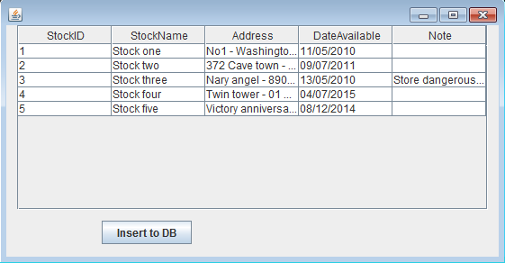

Data on the form is generated, when click “Insert to DB” button the data will be store in the database

Guidelines

